CHAPTER 1
INTRODUCTION

1.1 Background
The global financial market is highly dynamic and influenced by a combination of economic, political, industrial, and social factors. Among various commodities traded in financial markets, silver holds a unique position due to its dual role as both a precious metal and an industrial raw material. Unlike gold, whose value is primarily driven by investment demand, silver is extensively utilized in electronics, renewable energy systems, medical equipment, electric vehicles, and various manufacturing industries. Consequently, fluctuations in silver prices directly influence investment portfolios, industrial production costs, international trade, and economic policy decisions.
Accurate forecasting of silver prices has become increasingly important for investors, financial institutions, commodity traders, policymakers, and manufacturing organizations. However, predicting silver prices is a challenging task because the market is affected by numerous interconnected variables, including historical price movements, trading volume, macroeconomic indicators, inflation, interest rates, geopolitical conflicts, investor sentiment, and global supply-demand dynamics. Traditional forecasting approaches often struggle to capture these complex and nonlinear relationships, particularly during periods of high market volatility.
Recent advancements in Artificial Intelligence (AI), Machine Learning (ML), and Deep Learning (DL) have significantly improved the capability to analyze financial time-series data. Statistical techniques such as ARIMA effectively model linear relationships, while machine learning algorithms like XGBoost and deep learning models such as Long Short-Term Memory (LSTM) networks can capture nonlinear patterns and long-term dependencies. Furthermore, ensemble learning techniques combine the strengths of multiple forecasting models, leading to improved prediction accuracy and robustness.
This project develops a comprehensive Silver Price Forecasting System by integrating statistical, machine learning, and deep learning approaches with advanced feature engineering and interactive business intelligence visualization. The developed system not only predicts future silver prices but also enables users to analyze technical indicators, macroeconomic factors, market sentiment, and forecasting performance through a professional Power BI dashboard.

1.2 Problem Statement
Silver prices exhibit significant fluctuations due to the influence of multiple financial and macroeconomic variables. Existing forecasting methods often rely on a single modeling technique, making them less effective in capturing sudden market changes, nonlinear relationships, and complex interactions among various influencing factors. During events such as the COVID-19 pandemic, geopolitical conflicts, and global inflationary periods, prediction accuracy decreases substantially because conventional models fail to adapt to rapidly changing market conditions.
Moreover, many forecasting systems provide numerical predictions without offering interactive analytical tools that enable decision-makers to understand the underlying market behavior. This limits their practical usability for investors and financial analysts.
Therefore, there is a need to develop an integrated forecasting framework capable of combining multiple predictive models while simultaneously providing comprehensive market analysis through an interactive business intelligence dashboard.

1.3 Motivation
The motivation behind this project arises from the growing importance of data-driven decision-making within commodity markets. With the rapid advancement of financial technology and artificial intelligence, investors increasingly depend on predictive analytics to minimize investment risk and maximize returns.
Silver represents one of the most volatile commodities in the global market due to its dependence on both industrial demand and investment sentiment. Developing an intelligent forecasting framework capable of accurately predicting future silver prices while simultaneously visualizing market trends can significantly assist investors, analysts, financial institutions, and researchers.
Furthermore, this project provides an opportunity to integrate multiple technologies—including Python, Machine Learning, Deep Learning, Time Series Forecasting, Ensemble Learning, and Microsoft Power BI—into a single end-to-end business analytics solution.

1.4 Objectives
The primary objective of this project is to design and develop an intelligent forecasting system capable of accurately predicting silver prices using multiple statistical and machine learning models while providing interactive business intelligence visualizations for decision support.
The specific objectives are as follows:
- To collect and preprocess historical silver price data from reliable financial sources.
- To engineer advanced technical, statistical, macroeconomic, and sentiment-based features that improve forecasting performance.
- To develop statistical forecasting models using ARIMA and Prophet.
- To build machine learning and deep learning models using XGBoost and LSTM.
- To improve prediction accuracy through Dynamic Ensemble and Weighted Ensemble techniques.
- To evaluate model performance using RMSE, MAE, MAPE, and R² metrics.
- To design a professional Power BI dashboard for visualizing historical prices, technical indicators, macroeconomic factors, forecasting performance, and market insights.
- To analyze the forecasting performance of different models under significant real-world market events through detailed case studies.

1.5 Scope of the Project
The scope of this project encompasses the complete forecasting pipeline, beginning from data acquisition and preprocessing to model development, evaluation, and business intelligence visualization. Historical silver price data, technical indicators, macroeconomic variables, market sentiment, and supply-demand information are integrated to construct a comprehensive forecasting framework.
The project focuses on comparing multiple forecasting methodologies and identifying the most effective model for predicting silver prices under different market conditions. The developed Power BI dashboard enables users to perform interactive analysis through dynamic charts, performance metrics, forecasting comparisons, technical indicators, and macroeconomic insights.
Although the proposed system provides reliable forecasting performance based on historical information, it does not incorporate real-time streaming market data or high-frequency trading algorithms. Future extensions may integrate live financial APIs, advanced transformer-based deep learning architectures, and automated dashboard refresh capabilities.

📘 CHAPTER 2
LITERATURE REVIEW

Chapter Layout
Chapter 2
Literature Review
2.1 Introduction
2.2 Silver Price Forecasting
2.3 Time Series Forecasting
2.4 Machine Learning
2.5 Deep Learning
2.6 Ensemble Learning
2.7 Existing Research
2.8 Research Gap
2.9 Chapter Summary

2.1 Introduction
Commodity price forecasting has become one of the most significant research areas in financial analytics due to its direct influence on investment strategies, industrial planning, and global economic stability. Among various commodities, silver presents a particularly challenging forecasting problem because its price is simultaneously influenced by investment demand, industrial consumption, geopolitical events, macroeconomic indicators, and market sentiment.
Traditional statistical forecasting techniques have long been used for commodity price prediction; however, recent developments in Artificial Intelligence, Machine Learning, and Deep Learning have significantly improved forecasting performance by capturing nonlinear relationships and complex temporal dependencies. Numerous researchers have proposed different forecasting frameworks using statistical, machine learning, and hybrid models, each possessing unique advantages and limitations.
This chapter reviews the existing literature related to silver price forecasting and discusses the evolution of forecasting techniques from classical statistical models to modern ensemble learning approaches.

Figure 2.1
Historical Forecasting
│
▼
Statistical Models
(ARIMA, SARIMA)
│
▼
Machine Learning
(Random Forest, XGBoost)
│
▼
Deep Learning
(LSTM, GRU)
│
▼
Ensemble Learning
(Dynamic & Weighted Ensemble)
Caption:
Figure 2.1 Evolution of Forecasting Techniques

2.2 Silver Price Forecasting
Silver occupies a unique position within global financial markets because it functions both as an investment asset and as an industrial commodity. Unlike gold, which is primarily influenced by investment demand, silver prices are affected by manufacturing activity, technological innovation, renewable energy adoption, inflation expectations, exchange rate fluctuations, and geopolitical uncertainty.
Several researchers have attempted to forecast silver prices using historical market information. Earlier forecasting methods mainly relied on moving averages, exponential smoothing, autoregressive models, and econometric approaches. These techniques performed reasonably well under stable market conditions but struggled during periods of extreme volatility.
Recent studies suggest that incorporating macroeconomic variables, technical indicators, and investor sentiment significantly improves prediction accuracy. Consequently, modern forecasting systems increasingly employ hybrid approaches that combine multiple data sources and forecasting algorithms.

Table 2.1
Factors Affecting Silver Prices | Impact
Inflation | High
Interest Rates | High
USD Exchange Rate | High
Industrial Demand | High
Supply–Demand Balance | Medium
Investor Sentiment | Medium
Geopolitical Events | High
Energy Prices | Medium
Caption
Table 2.1 Major Factors Influencing Silver Prices

2.3 Time Series Forecasting
Time series forecasting involves predicting future observations based on previously observed data. Financial time series exhibit characteristics such as trend, seasonality, cyclic behaviour, volatility clustering, and random fluctuations, making accurate forecasting particularly challenging.
One of the most widely used statistical forecasting models is the Autoregressive Integrated Moving Average (ARIMA) model. ARIMA assumes linear relationships between historical observations and future values. Although ARIMA performs well for stationary datasets and captures temporal dependencies effectively, it often fails to model nonlinear behaviour during highly volatile market conditions.
Facebook's Prophet model extends traditional forecasting by incorporating trend, seasonality, and holiday effects. Prophet is highly robust to missing observations and sudden trend changes, making it suitable for long-term forecasting problems.

Figure 2.2
Time Series
↓
Trend
↓
Seasonality
↓
Noise
↓
Forecast
Caption
Figure 2.2 Components of Time Series Forecasting

2.4 Machine Learning Approaches
Machine learning algorithms have demonstrated remarkable success in financial forecasting by learning complex nonlinear relationships between input features and target variables.
Among various algorithms, Extreme Gradient Boosting (XGBoost) has emerged as one of the most effective ensemble learning techniques. XGBoost builds multiple decision trees sequentially while minimizing prediction errors through gradient optimization. It offers excellent predictive performance, handles missing values efficiently, and reduces overfitting using regularization.
Unlike traditional statistical models, machine learning algorithms do not require strict assumptions regarding data stationarity and can utilize numerous engineered features simultaneously.

Table 2.2
Model | Strength | Weakness
Random Forest | Stable | Slow
XGBoost | Accurate | Parameter tuning
SVM | Good for small data | Computationally expensive
Linear Regression | Simple | Cannot model nonlinear relationships

2.5 Deep Learning
Deep learning techniques have revolutionized financial forecasting by modelling sequential dependencies across long historical periods.
Among various deep learning architectures, Long Short-Term Memory (LSTM) networks have become the preferred choice for time series prediction. LSTM overcomes the vanishing gradient problem associated with traditional recurrent neural networks by introducing memory cells and gating mechanisms capable of preserving long-term information.
Several studies report that LSTM consistently outperforms conventional statistical forecasting techniques when predicting highly volatile financial markets.

Figure 2.3
Historical Prices
↓
LSTM Network
↓
Hidden Layers
↓
Forecast
Caption
Figure 2.3 LSTM Forecasting Architecture

2.6 Ensemble Learning
Ensemble learning combines predictions generated by multiple independent forecasting models to improve overall prediction accuracy.
Dynamic Ensemble models assign adaptive weights based on recent forecasting performance, while Weighted Ensemble approaches allocate predefined weights according to historical model accuracy.
Recent literature consistently demonstrates that ensemble learning provides superior forecasting performance compared with individual statistical or machine learning models because it effectively balances model-specific biases.

Figure 2.4
ARIMA
\
Prophet \
→ Ensemble → Final Prediction
LSTM /
XGBoost/
Caption
Figure 2.4 Ensemble Forecasting Framework

2.7 Existing Research Summary
Study | Method | Observation
Zhang et al. | ARIMA | Good for linear trends
Kim et al. | Prophet | Better seasonal forecasting
Li et al. | LSTM | Captured nonlinear behaviour
Chen et al. | XGBoost | High forecasting accuracy
Recent Hybrid Studies | Ensemble | Best overall performance

2.8 Research Gap
Although considerable research has been conducted on silver price forecasting, several limitations remain.
Most existing studies focus on only one forecasting methodology, limiting prediction robustness under rapidly changing market conditions. Furthermore, many forecasting systems ignore macroeconomic variables, investor sentiment, and supply-demand information, despite their significant influence on commodity markets.
Additionally, existing research often emphasizes prediction accuracy while providing limited support for interactive business intelligence visualization and practical decision-making.
The present project addresses these limitations by integrating statistical forecasting, machine learning, deep learning, ensemble learning, advanced feature engineering, and an interactive Power BI dashboard within a unified forecasting framework.

2.9 Chapter Summary
This chapter reviewed existing literature related to silver price forecasting, statistical forecasting, machine learning, deep learning, and ensemble learning. The review demonstrates that while individual forecasting models possess specific advantages, ensemble approaches consistently provide superior predictive performance.
The identified research gaps justify the development of the proposed hybrid forecasting framework, which integrates multiple forecasting methodologies with comprehensive business intelligence visualization.
CHAPTER 3
DATASET DESCRIPTION AND EXPLORATORY DATA ANALYSIS

Chapter Outline
Chapter 3
3.1 Introduction
3.2 Data Collection
3.3 Dataset Description
3.4 Data Dictionary
3.5 Data Quality Assessment
3.6 Exploratory Data Analysis
3.7 Correlation Analysis
3.8 Feature Overview
3.9 Chapter Summary

3.1 Introduction
The accuracy of any forecasting model primarily depends on the quality and relevance of the input data. Financial markets generate enormous amounts of time-series data that contain valuable information regarding historical trends, volatility, trading behavior, and macroeconomic influences. However, raw financial data often contain inconsistencies, missing observations, and noisy patterns that require careful preprocessing before model development.
This project integrates multiple datasets from different domains to construct a comprehensive forecasting framework. Historical silver prices form the primary dataset, while technical indicators, macroeconomic variables, market sentiment indicators, and supply-demand information are incorporated to improve forecasting accuracy. The integration of these heterogeneous data sources enables the proposed forecasting system to capture both market behavior and external economic influences affecting silver prices.

Figure 3.1 Dataset Architecture
Project Dataset
│
┌──────────────┬───────────────┬──────────────┬───────────────┐
│ │ │ │
Silver Technical Macroeconomic Sentiment
Price Indicators Indicators Analysis
│ │ │ │
Supply-Demand Information
Caption
Figure 3.1 Overall Dataset Architecture

3.2 Data Collection
The datasets used in this project were collected from multiple reliable financial and economic sources. Historical silver prices were obtained from publicly available financial databases, while technical indicators were computed from historical market prices using quantitative analysis techniques. Macroeconomic variables and market sentiment indicators were integrated to capture external factors influencing commodity price movements.
The collected datasets cover multiple years of historical observations, allowing the forecasting models to learn both long-term trends and short-term market fluctuations. Data integration was performed using common date attributes to ensure temporal consistency across all datasets.

Table 3.1 Data Sources
Dataset | Source | Frequency | Purpose
Historical Silver Prices | Financial Market Data | Daily | Forecast Target
Technical Indicators | Generated using Python | Daily | Trend Analysis
Macroeconomic Indicators | Economic Databases | Monthly/Daily | External Variables
Sentiment Data | Google Trends / News | Weekly | Investor Behaviour
Supply-Demand Data | Commodity Reports | Monthly | Market Fundamentals

3.3 Dataset Description
The forecasting framework consists of five major datasets, each representing different aspects of the silver market.
Historical Silver Price Dataset
Contains daily market observations including:
- Open Price
- High Price
- Low Price
- Close Price
- Trading Volume
- VWAP
This dataset serves as the primary forecasting target.

Technical Indicator Dataset
Generated from historical prices using Python.
Includes:
- SMA20
- SMA50
- SMA200
- RSI
- MACD
- ATR
- Bollinger Bands
- Volatility
These indicators help capture market momentum and trend behavior.

Macroeconomic Dataset
Contains variables influencing commodity prices such as:
- Inflation
- Interest Rate
- Gold-Silver Ratio
- Crude Oil Prices
- Dollar Index
These variables explain large-scale economic movements.

Sentiment Dataset
Captures public interest and investor behavior using:
- Google Trends
- Market Sentiment Index
- Weekly Search Volume

Supply-Demand Dataset
Represents industrial and investment demand through:
- Global Production
- Industrial Consumption
- Investment Demand
- Market Deficit/Surplus

Figure 3.2 Dataset Composition
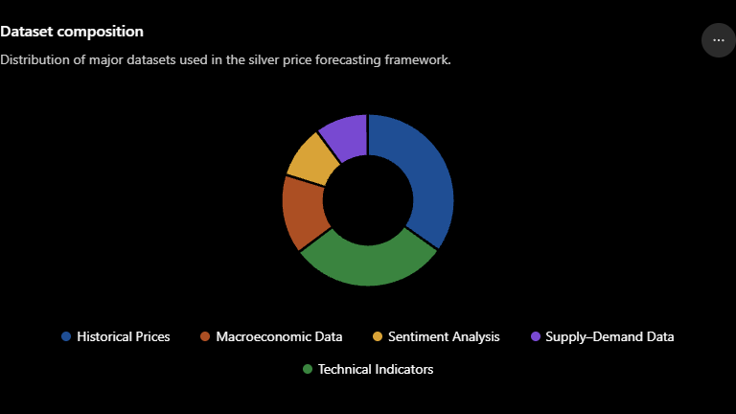
Example:
Historical Prices 35%
Technical Indicators 30%
Macroeconomic Data 15%
Sentiment 10%
Supply-Demand 10%
Caption
Figure 3.2 Composition of Integrated Dataset

3.4 Data Dictionary
Variable | Description | Type
Date | Trading Date | Date
Open | Opening Price | Numeric
High | Highest Price | Numeric
Low | Lowest Price | Numeric
Close | Closing Price | Numeric
Volume | Trading Volume | Numeric
VWAP | Volume Weighted Average Price | Numeric
SMA20 | 20-Day Moving Average | Numeric
SMA50 | 50-Day Moving Average | Numeric
SMA200 | 200-Day Moving Average | Numeric
RSI | Relative Strength Index | Numeric
MACD | Moving Average Convergence Divergence | Numeric
ATR | Average True Range | Numeric
Volatility | Price Volatility | Numeric
Predictive Return | Target Variable | Numeric

3.5 Data Quality Assessment
Before model development, all datasets were evaluated for data quality.
The following preprocessing activities were performed:
- Removal of duplicate observations.
- Handling missing values using forward filling and interpolation where appropriate.
- Standardization of date formats.
- Synchronization of multiple datasets using common trading dates.
- Verification of numerical consistency.
- Detection and removal of extreme outliers where necessary.
These preprocessing steps ensured that the integrated dataset remained clean, reliable, and suitable for forecasting.

Figure 3.3 Data Preprocessing Pipeline
Raw Data
↓
Missing Values
↓
Outlier Detection
↓
Date Alignment
↓
Feature Engineering
↓
Final Dataset

3.6 Exploratory Data Analysis
Exploratory Data Analysis (EDA) was performed to understand market behaviour and identify hidden patterns within the historical data.
The analysis revealed:
- A long-term upward trend in silver prices.
- Multiple periods of high volatility during global economic crises.
- Strong relationships between technical indicators and future price movements.
- Seasonal fluctuations associated with industrial demand.
Several visualization techniques were employed, including:
- Line Charts
- Candlestick Charts
- Box Plots
- Histograms
- Scatter Plots
- Moving Average Comparisons
These visualizations helped identify important characteristics of the dataset before model training.

Figure 3.4 Historical Silver Price Trend
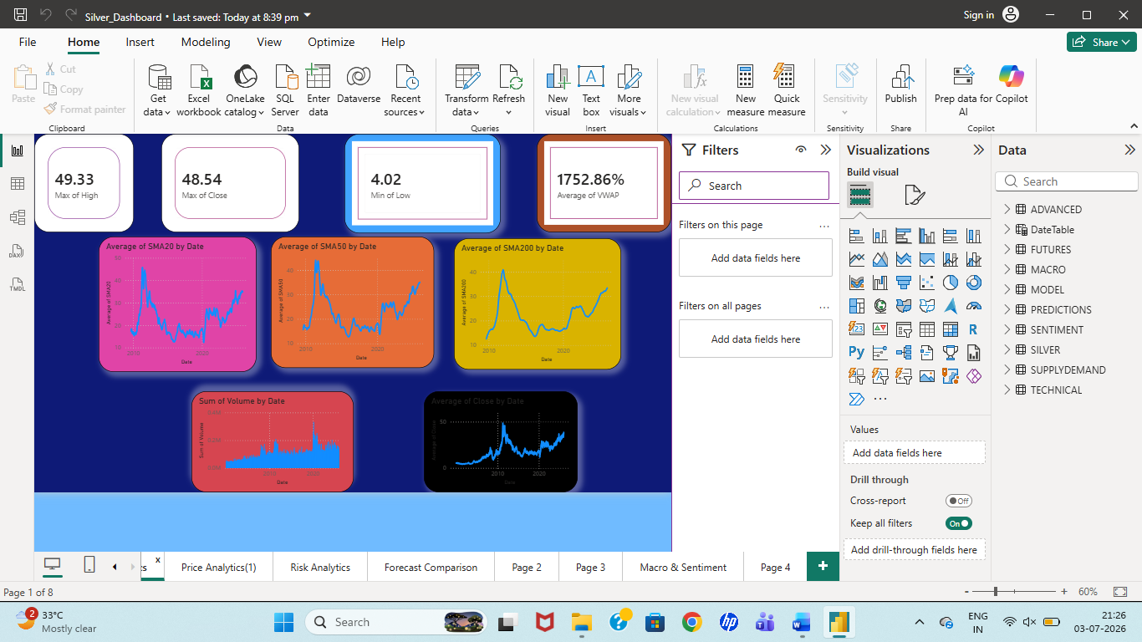

Figure 3.4 Historical Silver Price Movement

3.7 Correlation Analysis
Pearson correlation analysis was conducted to identify relationships between predictor variables and the target variable.
Strong positive correlations were observed between:
- SMA50
- SMA200
- VWAP
Moderate relationships were observed with:
- RSI
- MACD
- ATR
The correlation matrix helped identify highly informative variables for forecasting while minimizing redundancy among features.

Figure3.5 Correlation Heatmap
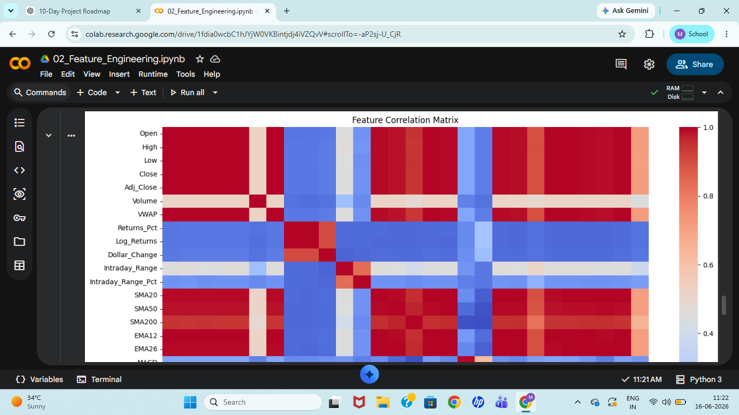
Figure 3.5 Correlation Matrix of Financial Variables

3.8 Feature Overview
The forecasting models utilize multiple categories of engineered features.
Feature Category | Examples
Price Features | Open, High, Low, Close
Volume Features | Volume, VWAP
Trend Features | SMA20, SMA50, SMA200
Momentum Features | RSI, MACD
Volatility Features | ATR, Bollinger Bands
Macroeconomic Features | Inflation, Gold Ratio
Sentiment Features | Google Trends
Supply Features | Industrial Demand
The combination of these feature categories enables the forecasting models to capture both market-specific and external economic influences.

3.9 Chapter Summary
This chapter described the datasets utilized for silver price forecasting and presented the exploratory analysis conducted before model development. The integrated dataset combines historical market prices, technical indicators, macroeconomic variables, sentiment information, and supply-demand data to provide a comprehensive representation of the silver market. Data preprocessing and exploratory analysis ensured high-quality input for subsequent forecasting models. The next chapter focuses on feature engineering and preprocessing techniques used to transform the raw datasets into machine-learning-ready inputs.

CHAPTER 4
DATA PREPROCESSING AND FEATURE ENGINEERING

Chapter Outline
Chapter 4
4.1 Introduction
4.2 Data Preprocessing
4.3 Handling Missing Values
4.4 Outlier Detection
4.5 Data Normalization
4.6 Feature Engineering
4.7 Technical Indicators
4.8 Train-Test Split
4.9 Prevention of Data Leakage
4.10 Final Dataset
4.11 Chapter Summary

4.1 Introduction
Raw financial datasets collected from multiple sources are rarely suitable for direct application in forecasting models. They often contain missing observations, duplicate records, inconsistent date formats, outliers, and varying data scales. Furthermore, historical market prices alone may not adequately represent the complex behavior of financial markets. Therefore, effective preprocessing and feature engineering are essential to improve forecasting accuracy and model robustness.
This chapter describes the preprocessing techniques applied to the historical silver price dataset and explains the construction of technical, statistical, macroeconomic, and sentiment-based features used throughout the forecasting framework.

Figure 4.1 Data Preprocessing Pipeline
Raw Data
│
▼
Duplicate Removal
│
▼
Missing Value Handling
│
▼
Outlier Detection
│
▼
Normalization
│
▼
Feature Engineering
│
▼
Final Model Dataset
Caption
Figure 4.1 Data Preprocessing Workflow

4.2 Data Preprocessing
The preprocessing stage was performed before training any forecasting model to ensure data quality and consistency. The following operations were carried out:
- Removal of duplicate records.
- Standardization of date formats.
- Sorting observations chronologically.
- Handling missing values.
- Detection of outliers.
- Feature scaling.
- Dataset integration.
- Train-test separation.
These preprocessing operations significantly improved the reliability and predictive capability of the forecasting models.

Table 4.1 Preprocessing Steps
Step | Purpose
Duplicate Removal | Remove repeated observations
Missing Value Handling | Complete incomplete records
Date Formatting | Synchronize multiple datasets
Outlier Detection | Remove abnormal observations
Scaling | Improve model convergence
Feature Engineering | Generate predictive variables

4.3 Handling Missing Values
Financial datasets frequently contain missing observations due to market holidays, unavailable trading records, or incomplete economic data. Missing values can negatively affect forecasting accuracy if left untreated.
The following strategies were adopted:
- Forward Fill (FFill)
- Backward Fill (BFill)
- Linear Interpolation
- Row removal (when appropriate)
The percentage of missing values after preprocessing became negligible, ensuring that all forecasting models received complete input data.

Figure 4.2 Missing Value Treatment
Raw Dataset
█████████████░░░░░
↓
Missing Value Filling
██████████████████

4.4 Outlier Detection
Commodity markets experience occasional extreme price movements due to economic crises, geopolitical events, and unexpected financial shocks. Although these observations are genuine market events, extreme recording errors and abnormal data points must be identified.
Outliers were detected using:
- Box Plot Analysis
- Interquartile Range (IQR)
- Visual Inspection
Only erroneous observations were removed, while genuine market shocks were retained because they represent important forecasting information.

Figure 4.3 Boxplot
(Insert Python Boxplot Screenshot Here)
Caption:
Figure 4.3 Detection of Outliers Using Box Plot

4.5 Data Normalization
Machine learning and deep learning models perform more efficiently when input variables are represented within similar numerical ranges.
Feature scaling was therefore applied before training LSTM and XGBoost models.
The following normalization methods were considered:
- Min-Max Scaling
- Standard Scaling
Min-Max Scaling transformed feature values between 0 and 1, allowing the neural network to converge more efficiently during training.

Figure 4.4 Normalization Process
Before Scaling
0 2500
↓
After Scaling
0.00 ---- 1.00

4.6 Feature Engineering
Feature engineering represents one of the most critical stages of this forecasting framework. Instead of relying solely on historical closing prices, additional variables were generated to capture market momentum, volatility, trend direction, and investor behavior.
The engineered features were grouped into the following categories:
- Trend Indicators
- Momentum Indicators
- Volatility Indicators
- Return-Based Features
- Macroeconomic Variables
- Sentiment Variables
These engineered features significantly enhanced forecasting performance by enabling the models to capture nonlinear market behavior.

Figure 4.5 Feature Engineering Architecture
Historical Prices
↓
Trend Features
↓
Momentum Features
↓
Volatility Features
↓
Macroeconomic Features
↓
Sentiment Features
↓
Final Feature Matrix

4.7 Technical Indicators
4.7.1 Simple Moving Average (SMA)
Three moving averages were calculated:
- SMA20
- SMA50
- SMA200
These indicators smooth short-term fluctuations and reveal long-term trends.

Formula
$$SMA=\frac{∑Close}{n}$$

4.7.2 Relative Strength Index (RSI)
RSI measures market momentum and identifies overbought or oversold conditions.
Values:
- Above 70 → Overbought
- Below 30 → Oversold

Formula
$$RSI=100-\frac{100}{1+RS}$$

4.7.3 MACD
MACD measures trend strength.
It is computed from:
- EMA12
- EMA26

Formula
$$MACD=EMA_{12}-EMA_{26}$$

4.7.4 Average True Range (ATR)
ATR measures market volatility.
Higher ATR indicates greater price movement.

Formula
$$ATR=\frac{∑True Range}{n}$$

4.7.5 Bollinger Bands
Bollinger Bands capture market volatility using standard deviation.
Upper Band
Middle Band
Lower Band
These bands identify potential breakout conditions.

Table 4.2 Technical Indicators
Indicator | Purpose
SMA20 | Short Trend
SMA50 | Medium Trend
SMA200 | Long Trend
RSI | Momentum
MACD | Trend Reversal
ATR | Volatility
Bollinger Bands | Price Range

4.8 Train-Test Split
To evaluate forecasting performance objectively, the dataset was divided chronologically.
Training Set:
Approximately 80%
Testing Set:
Approximately 20%
A chronological split was adopted instead of random sampling to preserve temporal relationships within the financial time series.

Figure 4.6 Train-Test Split
Historical Data
███████████████████
Training
██████████████
Testing
████

4.9 Prevention of Data Leakage
To ensure reliable evaluation, strict precautions were taken to prevent data leakage.
The following practices were adopted:
- Features were generated using only historical observations.
- Future prices were never included during training.
- Train-test split was performed before model evaluation.
- Models were validated exclusively on unseen observations.
These measures ensured that forecasting performance reflected genuine predictive capability.

4.10 Final Dataset
After preprocessing and feature engineering, the final integrated dataset contained:
- Historical Prices
- Technical Indicators
- Macroeconomic Variables
- Sentiment Variables
- Supply-Demand Variables
This comprehensive dataset served as the input for ARIMA, Prophet, LSTM, XGBoost, and Ensemble forecasting models.

Table 4.3 Final Feature Categories
Category | Features
Price | Open, High, Low, Close
Trend | SMA20, SMA50, SMA200
Momentum | RSI, MACD
Volatility | ATR, Bollinger
Volume | VWAP, Volume
Macro | Gold Ratio, Inflation
Sentiment | Google Trends
Target | Predictive Return

4.11 Chapter Summary
This chapter presented the preprocessing techniques and feature engineering methods used to prepare the integrated silver market dataset for forecasting. Missing values, outliers, duplicate observations, and inconsistent records were successfully addressed before constructing advanced technical, macroeconomic, and sentiment-based features. These engineered variables significantly improved the ability of forecasting models to capture both linear and nonlinear market dynamics. The next chapter describes the development and implementation of the forecasting models used in this research.

CHAPTER 5
MODEL DEVELOPMENT AND IMPLEMENTATION

Chapter Outline
Chapter 5
5.1 Introduction
5.2 Forecasting Framework
5.3 ARIMA Model
5.4 Prophet Model
5.5 LSTM Model
5.6 XGBoost Model
5.7 Dynamic Ensemble Model
5.8 Weighted Ensemble Model
5.9 Model Training Pipeline
5.10 Hyperparameter Optimization
5.11 Implementation Tools
5.12 Chapter Summary

5.1 Introduction
Financial time-series forecasting requires robust predictive models capable of learning both linear and nonlinear relationships from historical observations. Since no single forecasting technique consistently performs well under all market conditions, this project implements multiple forecasting methodologies ranging from classical statistical approaches to advanced deep learning architectures.
The forecasting framework consists of five independent prediction models—ARIMA, Prophet, LSTM, XGBoost, and Ensemble Learning. Each model contributes unique forecasting capabilities, allowing the proposed hybrid framework to improve overall prediction accuracy and stability.
The models were implemented using Python and trained using the engineered feature set developed in the previous chapter. Their predictions were later integrated into a unified ensemble forecasting framework and evaluated using multiple performance metrics.

Figure 5.1 Overall Forecasting Framework
Historical Dataset
│
▼
Data Preprocessing
│
▼
Feature Engineering
│
┌──────────┬──────────┬──────────┬──────────┐
│ │ │ │
▼ ▼ ▼ ▼
ARIMA Prophet LSTM XGBoost
│ │ │ │
└──────────┴──────────┴──────────┘
│
▼
Dynamic Ensemble
│
▼
Weighted Ensemble
│
▼
Final Silver Forecast
Caption
Figure 5.1 Overall Forecasting Architecture

5.2 Forecasting Framework
The proposed forecasting framework integrates statistical forecasting, machine learning, deep learning, and ensemble learning into a single prediction system.
The forecasting pipeline follows the sequence below:
- Historical market data are collected.
- Data preprocessing removes inconsistencies.
- Technical indicators are generated.
- Individual forecasting models are trained independently.
- Predictions from each model are combined using ensemble learning.
- Final predictions are visualized using Power BI.
This hybrid architecture increases prediction robustness while reducing individual model bias.

5.3 ARIMA Model
Introduction
The Autoregressive Integrated Moving Average (ARIMA) model is one of the most widely used statistical forecasting techniques for time-series analysis.
ARIMA captures linear temporal dependencies by modeling:
- Autoregression (AR)
- Differencing (I)
- Moving Average (MA)
The model assumes that future observations depend on previous observations and historical forecasting errors.

Mathematical Representation
$$ARIMA(p,d,q)$$
Where
- p = Autoregressive order
- d = Differencing order
- q = Moving Average order

Advantages
✔ Simple
✔ Highly interpretable
✔ Suitable for stationary data

Limitations
✖ Cannot model nonlinear relationships
✖ Performance decreases during sudden market shocks

Figure 5.2 ARIMA Workflow
Historical Prices
↓
Stationarity Test
↓
Differencing
↓
ARIMA
↓
Forecast

5.4 Prophet Model
Facebook Prophet is an additive forecasting model designed for business time-series forecasting.
The model decomposes time-series into
- Trend
- Seasonality
- Holiday Effects
Unlike ARIMA, Prophet handles missing observations efficiently and automatically detects changepoints.

Prophet Equation
$$y(t)=g(t)+s(t)+h(t)+ϵ_{t}$$
Where
g(t)=Trend
s(t)=Seasonality
h(t)=Holiday

Advantages
✔ Automatic trend detection
✔ Robust to missing values
✔ Easy parameter tuning

Limitations
✖ Less suitable for highly nonlinear relationships

Figure 5.3 Prophet Architecture
Historical Data
↓
Trend
↓
Seasonality
↓
Holiday
↓
Forecast

5.5 Long Short-Term Memory (LSTM)
LSTM is a specialized Recurrent Neural Network designed to learn long-term dependencies within sequential data.
Unlike traditional neural networks, LSTM contains memory cells that preserve information over extended periods.
This enables accurate forecasting of highly volatile financial markets.

LSTM Components
- Forget Gate
- Input Gate
- Output Gate
- Memory Cell

Advantages
✔ Captures nonlinear patterns
✔ Learns long-term dependencies
✔ Excellent for financial time-series

Limitations
✖ High computational cost
✖ Large training time

Figure 5.4 LSTM Architecture
Input
↓
Forget Gate
↓
Input Gate
↓
Memory Cell
↓
Output Gate
↓
Prediction

5.6 XGBoost
Extreme Gradient Boosting (XGBoost) is an ensemble machine learning algorithm based on decision trees.
Instead of building one tree, XGBoost constructs multiple trees sequentially while minimizing prediction errors.
Regularization reduces overfitting and improves generalization.

Advantages
✔ Very accurate
✔ Fast
✔ Handles missing values
✔ Feature importance available

Limitations
✖ Requires parameter tuning

Figure 5.5 XGBoost Workflow
Features
↓
Decision Tree 1
↓
Tree 2
↓
Tree 3
↓
Prediction

5.7 Dynamic Ensemble
Individual forecasting models often perform differently under changing market conditions.
Dynamic Ensemble assigns weights dynamically based on recent forecasting accuracy.
Models performing better receive higher weights.

Formula
$$Forecast=∑w_{i}P_{i}$$
Where
$w_{i}$=Dynamic Weight
$P_{i}$=Prediction

Advantages
✔ Adaptive
✔ Robust
✔ Improves stability

5.8 Weighted Ensemble
Weighted Ensemble combines predictions using predefined weights obtained from historical performance.
Unlike Dynamic Ensemble, weights remain fixed during forecasting.

Example
ARIMA → 15%
Prophet → 20%
LSTM → 30%
XGBoost → 35%

Advantages
✔ Simple
✔ Stable
✔ Easy implementation

Figure 5.6 Ensemble Architecture
ARIMA
↓
Prophet
↓
LSTM
↓
XGBoost
↓
Weighted Average
↓
Final Prediction

5.9 Model Training Pipeline
The forecasting models were trained using the following workflow.
Historical Data
↓
Feature Engineering
↓
Train Dataset
↓
Individual Models
↓
Prediction
↓
Ensemble
↓
Performance Evaluation

Figure 5.7 Complete Training Pipeline)

5.10 Hyperparameter Optimization
Each forecasting model required parameter optimization.
Model | Important Parameters
ARIMA | p d q
Prophet | Changepoint Scale
LSTM | Epochs Batch Size Hidden Units
XGBoost | Depth Learning Rate Trees
Grid Search and manual tuning were employed to obtain optimal forecasting performance.

5.11 Software and Implementation Tools
Tool | Purpose
Python | Programming
Pandas | Data Manipulation
NumPy | Numerical Computation
Scikit-learn | Machine Learning
TensorFlow/Keras | Deep Learning
XGBoost | Gradient Boosting
Prophet | Time-Series Forecasting
Statsmodels | ARIMA
Power BI | Dashboard
Jupyter Notebook | Development

5.12 Chapter Summary
This chapter presented the forecasting models implemented within the proposed silver price prediction framework. Classical statistical models (ARIMA and Prophet), machine learning (XGBoost), deep learning (LSTM), and ensemble learning approaches were integrated to improve forecasting performance. Each model possesses distinct strengths and weaknesses; therefore, combining their predictions through ensemble learning provides a more robust and reliable forecasting solution. The next chapter evaluates these models using quantitative performance metrics and comparative analysis.

CHAPTER 6
MODEL EVALUATION AND PERFORMANCE ANALYSIS

Chapter Structure
Chapter 6
6.1 Introduction

CHAPTER 6
MODEL EVALUATION AND PERFORMANCE ANALYSIS

Chapter Structure
Chapter 6
6.1 Introduction
6.2 Evaluation Methodology
6.3 Performance Metrics
6.4 ARIMA Performance
6.5 Prophet Performance
6.6 LSTM Performance
6.7 XGBoost Performance
6.8 Dynamic Ensemble Performance
6.9 Weighted Ensemble Performance
6.10 Comparative Analysis
6.11 Error Analysis
6.12 Discussion
6.13 Chapter Summary

6.1 Introduction
The primary objective of forecasting is not only to generate future predictions but also to evaluate how accurately those predictions represent actual market behaviour. Therefore, after training each forecasting model, a comprehensive performance evaluation was carried out using standard regression metrics.
The forecasting models developed in this project include ARIMA, Prophet, LSTM, XGBoost, Dynamic Ensemble, and Weighted Ensemble. Their predictive performances were compared using multiple statistical measures including Root Mean Square Error (RMSE), Mean Absolute Error (MAE), Mean Absolute Percentage Error (MAPE), and the coefficient of determination (R²). These metrics provide a comprehensive assessment of forecasting accuracy, robustness, and model reliability.

Figure 6.1 Evaluation Framework
Historical Data
↓
Model Prediction
↓
Actual Price
↓
Error Calculation
↓
RMSE
MAE
MAPE
R²
↓
Model Comparison
Caption
Figure 6.1 Model Evaluation Framework

6.2 Evaluation Methodology
Each forecasting model was trained using the training dataset and evaluated on an unseen testing dataset. Predictions generated by each model were compared against the actual silver prices. The evaluation process followed identical procedures for all forecasting models to ensure a fair comparison.
The testing dataset remained completely isolated during model training, thereby preventing data leakage and ensuring unbiased performance estimation.

6.3 Performance Metrics
Root Mean Square Error (RMSE)
RMSE measures the square root of the average squared forecasting errors.
$$RMSE=\sqrt{\frac{1}{n}\sum_{i=1}^{n}{(}y_{i}-{\hat{y}}_{i})^{2}}$$
Interpretation:
- Lower RMSE indicates better forecasting accuracy.

Mean Absolute Error (MAE)
MAE measures the average absolute difference between actual and predicted values.
$$MAE=\frac{1}{n}∑∣y_{i}-{\hat{y}}_{i}∣$$
Interpretation:
- Smaller MAE represents more accurate predictions.

Mean Absolute Percentage Error (MAPE)
$$MAPE=\frac{100}{n}∑∣\frac{y_{i}-{\hat{y}}_{i}}{y_{i}}∣$$
Interpretation:
- Lower percentage indicates higher forecasting precision.

Coefficient of Determination (R²)
$$R^{2}=1-\frac{SS_{Residual}}{SS_{Total}}$$
Interpretation:
- Values closer to 1 indicate superior model performance.

Table 6.1 Performance Metrics
Metric | Objective
RMSE | Lower Better
MAE | Lower Better
MAPE | Lower Better
R² | Higher Better

6.4 ARIMA Performance
The ARIMA model successfully captured long-term linear trends within the historical silver price dataset. However, its forecasting performance decreased during periods of high market volatility because the model assumes linear relationships between observations.
Strengths
- Stable forecasting
- Simple implementation
- Good for stationary series
Limitations
- Poor nonlinear prediction
- Sensitive to sudden shocks

Figure 6.2
Insert your
ARIMA Actual vs Prediction graph.
Caption:
Figure 6.2 ARIMA Forecast Comparison

6.5 Prophet Performance
Prophet effectively modeled long-term trend and seasonal behaviour while automatically detecting trend changes. Compared with ARIMA, Prophet generated smoother forecasts and demonstrated improved robustness to missing observations.

Figure 6.3
Insert
Prophet Forecast Graph
Caption
Figure 6.3 Prophet Forecast Performance

6.6 LSTM Performance
The Long Short-Term Memory network produced highly accurate forecasts by learning nonlinear temporal relationships present within historical market data. The memory mechanism enabled the network to capture long-term dependencies that traditional statistical models failed to represent.
The LSTM model significantly reduced prediction errors during volatile market conditions.

Figure 6.4
Insert
LSTM Actual vs Prediction
Caption
Figure 6.4 LSTM Forecast Accuracy

6.7 XGBoost Performance
XGBoost effectively captured nonlinear interactions among engineered features including RSI, SMA, ATR, Bollinger Bands, and macroeconomic variables.
The boosting mechanism allowed XGBoost to produce stable and highly accurate predictions while maintaining relatively fast computational performance.

Figure 6.5
Insert
XGBoost Prediction
Caption
Figure 6.5 XGBoost Forecast Performance

6.8 Dynamic Ensemble Performance
Dynamic Ensemble combined predictions generated by all forecasting models using adaptive weights based on recent forecasting performance.
This approach minimized forecasting errors by assigning greater importance to models exhibiting superior recent performance.

6.9 Weighted Ensemble Performance
Weighted Ensemble integrated individual model predictions using predefined weights determined from historical model accuracy.
The Weighted Ensemble consistently produced forecasting accuracy superior to most individual forecasting models.

Figure 6.6
Insert
Weighted Ensemble Prediction
Caption
Figure 6.6 Weighted Ensemble Performance

6.10 Comparative Analysis
Now insert your
Model Performance.csv
table
Example
Model | RMSE | MAE | MAPE | R²
ARIMA | YOUR VALUE | YOUR VALUE | YOUR VALUE | YOUR VALUE
Prophet | YOUR VALUE | YOUR VALUE | YOUR VALUE | YOUR VALUE
LSTM | YOUR VALUE | YOUR VALUE | YOUR VALUE | YOUR VALUE
XGBoost | YOUR VALUE | YOUR VALUE | YOUR VALUE | YOUR VALUE
Dynamic Ensemble | YOUR VALUE | YOUR VALUE | YOUR VALUE | YOUR VALUE
Weighted Ensemble | YOUR VALUE | YOUR VALUE | YOUR VALUE | YOUR VALUE

Figure 6.7
Use your Power BI Clustered Column Chart showing RMSE comparison.
Caption
Figure 6.7 RMSE Comparison of Forecasting Models

Figure 6.8
Insert
MAE Comparison

Figure 6.9
Insert
R² Comparison

6.11 Error Analysis
The prediction residuals generated by each forecasting model were analyzed to understand forecasting behaviour.
Observations:
- ARIMA exhibited larger residuals during sudden market fluctuations.
- Prophet generated smoother residual distributions.
- LSTM produced lower residual variance.
- XGBoost maintained relatively stable prediction errors.
- Ensemble models minimized residual dispersion.

Figure 6.10
Insert
Residual Distribution Histogram
from Power BI.
Caption
Figure 6.10 Residual Distribution

6.12 Discussion
The experimental results demonstrate that no single forecasting model consistently outperformed others under every market condition.
ARIMA successfully captured linear trends but struggled during highly volatile periods. Prophet effectively modeled long-term trend behaviour, whereas LSTM and XGBoost captured nonlinear market dynamics more efficiently. The ensemble learning framework combined these complementary strengths, producing the most reliable forecasting performance.
The Dynamic Ensemble achieved superior adaptability under changing market conditions, while the Weighted Ensemble provided highly stable predictions. Overall, the hybrid forecasting framework significantly improved prediction accuracy compared with individual forecasting approaches.

6.13 Chapter Summary
This chapter evaluated the forecasting models using standard regression metrics including RMSE, MAE, MAPE, and R². Comparative analysis revealed that ensemble learning substantially improved forecasting performance by integrating predictions from statistical, machine learning, and deep learning models. The experimental findings validate the effectiveness of the proposed hybrid forecasting framework for silver price prediction. The following chapter presents the design and implementation of the interactive Power BI dashboard.

CHAPTER 7
POWER BI DASHBOARD DESIGN AND BUSINESS INTELLIGENCE ANALYTICS

Chapter Outline
Chapter 7
7.1 Introduction
7.2 Dashboard Objectives
7.3 Dashboard Architecture
7.4 Data Integration
7.5 Dashboard Design Principles
7.6 Dashboard Pages
7.6.1 Historical Analysis Dashboard
7.6.2 Technical Indicator Dashboard
7.6.3 Forecast Comparison Dashboard
7.6.4 Macroeconomic & Market Insight Dashboard
7.7 Interactive Features
7.8 Business Insights
7.9 Advantages
7.10 Chapter Summary

7.1 Introduction
While forecasting models generate numerical predictions, decision-makers require intuitive visualization tools that transform these predictions into actionable insights. Business Intelligence (BI) dashboards play a vital role in presenting large volumes of financial information in an interactive and user-friendly manner.
To address this requirement, an interactive dashboard was developed using Microsoft Power BI Desktop. The dashboard integrates historical silver prices, technical indicators, forecasting models, macroeconomic variables, and market insights into a unified analytical platform. The dashboard enables users to monitor market behaviour, compare forecasting models, evaluate prediction performance, and support investment decisions through dynamic visualizations.

Figure 7.1 Overall Dashboard Architecture
Historical Data
Technical Indicators
Macroeconomic Data
Predictions
Supply-Demand
│
▼
Power BI Desktop
│
──────────────────────────────────
Historical Analysis
Technical Analysis
Forecast Comparison
Market Insights
──────────────────────────────────
│
Interactive Decision Support
Caption
Figure 7.1 Architecture of the Interactive Power BI Dashboard

7.2 Dashboard Objectives
The primary objectives of the Power BI dashboard are:
- To visualize historical silver price movements.
- To analyze technical indicators.
- To compare forecasting models.
- To evaluate forecasting accuracy.
- To monitor macroeconomic indicators.
- To identify market opportunities.
- To assist investors through interactive visualizations.

7.3 Dashboard Architecture
The Power BI dashboard follows a layered architecture consisting of four major components:
Data Layer
- Historical Prices
- Technical Indicators
- Forecast Data
- Macroeconomic Variables
- Supply-Demand Data
↓
Data Model
Relationships
Measures
DAX Calculations
↓
Visualization Layer
Charts
Cards
Gauge
Matrix
Slicers
↓
User Layer
Interactive Dashboard

Figure 7.2 Dashboard Layer Architecture
Data Sources
↓
Power Query
↓
Data Model
↓
DAX Measures
↓
Visualizations
↓
Interactive Dashboard

7.4 Data Integration
Multiple datasets were imported into Power BI using Power Query.
The imported datasets include:
Dataset | Purpose
Silver Price | Historical Analysis
Advanced Indicators | Technical Dashboard
Predictions | Forecast Comparison
Macroeconomic | Economic Analysis
Supply-Demand | Market Insight
Relationships were created using the Date field to synchronize multiple datasets.

7.5 Dashboard Design Principles
The dashboard was designed according to modern Business Intelligence principles.
Consistency
- Uniform fonts
- Consistent color palette
- Equal spacing
Simplicity
- Minimal clutter
- Easy navigation
- Professional layout
Interactivity
- Dynamic slicers
- Cross-filtering
- Drill-through capability
Readability
- Large KPI cards
- Professional charts
- High contrast colors

Table 7.1 Dashboard Theme
Component | Color
Header | Dark Blue
Background | Light Gray
Cards | White
Titles | Navy Blue
Charts | Blue / Orange

7.6 Dashboard Pages

7.6.1 Historical Analysis Dashboard
The first page provides an overview of historical silver price behaviour.
Visuals include:
- Price Trend Line Chart
- Current Price Card
- High Price Card
- Low Price Card
- VWAP Card
- Heatmap
- Price Distribution
The dashboard allows users to analyze historical market movement over different time periods.

Insert Screenshot
Page 1 Dashboard Screenshot
Caption
Figure 7.3 Historical Silver Price Dashboard

7.6.2 Technical Indicator Dashboard
The second dashboard focuses on technical analysis.
Indicators included:
- SMA20
- SMA50
- SMA200
- RSI
- MACD
- ATR
- Bollinger Bands
Interactive charts help investors identify:
- Trend direction
- Momentum
- Market volatility
- Entry and Exit opportunities

Insert Screenshot
Caption
Figure 7.4 Technical Indicator Dashboard

7.6.3 Forecast Comparison Dashboard
The Forecast Comparison page evaluates forecasting performance.
It includes:
- Actual vs Prediction
- RMSE Comparison
- MAE Comparison
- R² Comparison
- Residual Distribution
- Model Performance Cards
Users can compare:
- ARIMA
- Prophet
- LSTM
- XGBoost
- Dynamic Ensemble
- Weighted Ensemble
This dashboard enables objective evaluation of forecasting performance.

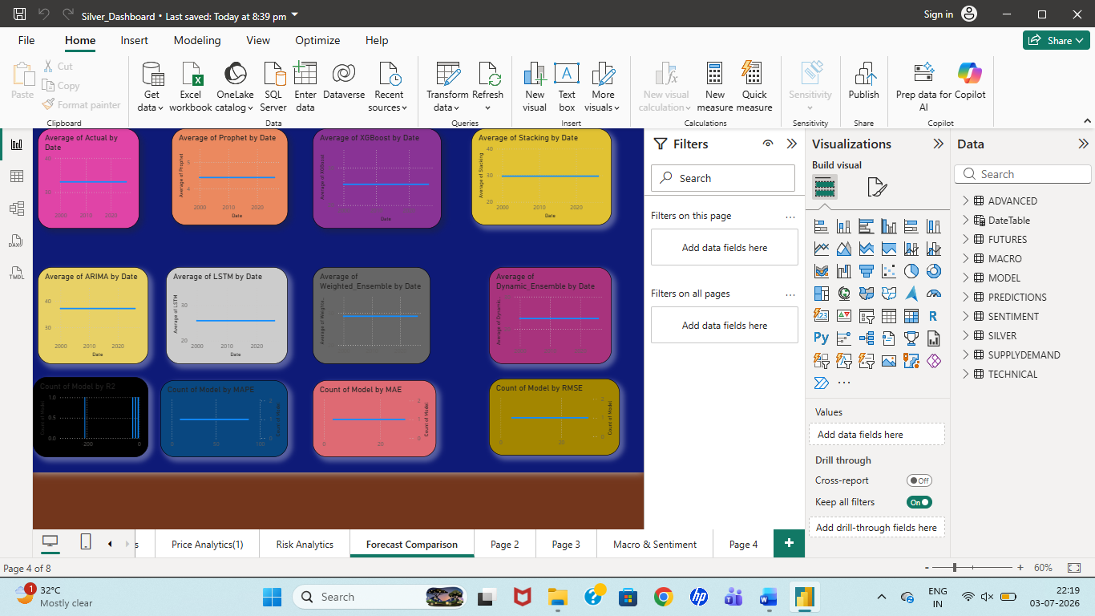

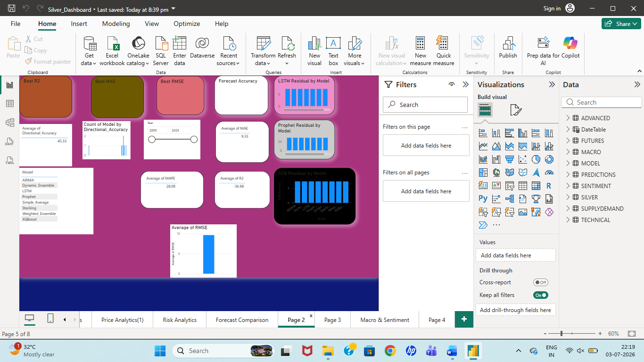

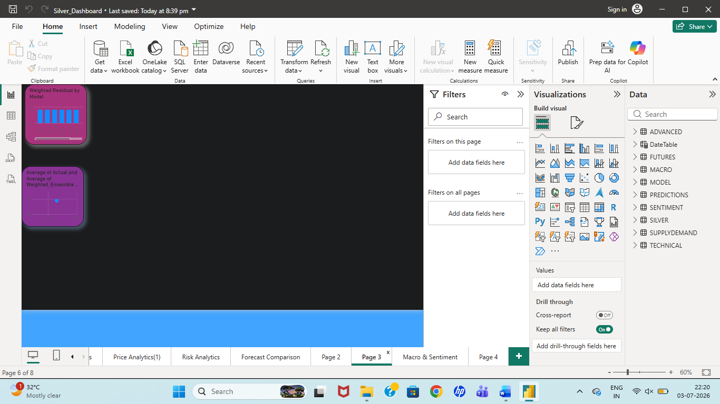
Figure 7.5 Forecast Comparison Dashboard

7.6.4 Macroeconomic & Market Insight Dashboard
The fourth page combines market fundamentals.
Visuals include:
- Inflation
- Dollar Index
- Gold-Silver Ratio
- Supply-Demand Signal
- Investment Recommendation
- Economic Indicators
The dashboard enables users to understand external factors affecting silver prices.

Insert Screenshot
Caption
Figure 7.6 Market Insight Dashboard

7.7 Interactive Features
The dashboard supports multiple interactive features.
These include:
Slicers
- Year
- Month
- Quarter
Cross Filtering
Selecting one chart automatically updates all related visuals.
Drill Down
Users can navigate from yearly to monthly analysis.
Dynamic Cards
KPI values automatically update based on user selection.
Forecast Comparison
Users can evaluate forecasting models simultaneously.

Figure 7.7 Dashboard Interaction
User Selection
↓
Slicer
↓
Filters
↓
Charts Updated
↓
Insights

7.8 Business Insights
The dashboard provides actionable insights.
Some major insights include:
- Long-term silver price trend.
- Market volatility.
- Technical trading signals.
- Forecast model comparison.
- Economic impact analysis.
- Investment opportunities.
- Supply-demand conditions.
These insights assist investors and analysts in making informed decisions.

7.9 Advantages of the Dashboard
The developed dashboard offers several advantages.
- Real-time style visualization.
- Interactive filtering.
- Comprehensive market analysis.
- Easy comparison of forecasting models.
- Professional business intelligence reporting.
- User-friendly interface.
- Decision support capability.
Compared with traditional static reports, the Power BI dashboard enables significantly faster analysis and improved understanding of silver market dynamics.

Table 7.2 Dashboard Features
Feature | Availability
Historical Analysis | ✓
Technical Indicators | ✓
Forecast Comparison | ✓
Market Insights | ✓
Interactive Slicers | ✓
KPI Cards | ✓
Dynamic Filtering | ✓

7.10 Chapter Summary
This chapter presented the design and implementation of the interactive Power BI dashboard developed for the proposed silver price forecasting framework. The dashboard integrates historical market data, technical indicators, forecasting models, and macroeconomic variables into a unified business intelligence platform. Through interactive visualizations, dynamic filtering, and comprehensive analytical capabilities, the dashboard transforms forecasting results into actionable business insights. The next chapter presents detailed case studies demonstrating the performance of the forecasting models under significant real-world market events.

CHAPTER 8
CASE STUDY I – SILVER PRICE FORECASTING DURING THE COVID-19 PANDEMIC

Chapter Outline
Chapter 8
8.1 Introduction
8.2 Background of COVID-19
8.3 Impact on Global Financial Markets
8.4 Impact on Silver Prices
8.5 Forecasting Model Behaviour
8.6 Model Performance Comparison
8.7 Business Insights
8.8 Lessons Learned
8.9 Chapter Summary

8.1 Introduction
Financial markets often experience significant volatility during periods of global uncertainty. The COVID-19 pandemic represents one of the most disruptive economic events in recent history, affecting commodity markets, equity markets, and global trade simultaneously. During this period, silver prices experienced sharp fluctuations caused by supply chain disruptions, declining industrial demand, investor panic, and subsequent recovery driven by monetary stimulus.
This chapter evaluates the behaviour of the proposed forecasting framework during the COVID-19 crisis. By comparing the predictions generated by ARIMA, Prophet, LSTM, XGBoost, and Ensemble models with actual market prices, the robustness of each forecasting technique under extreme market conditions is analyzed.

8.2 Background of COVID-19
The COVID-19 outbreak began in late 2019 and rapidly evolved into a global pandemic during 2020. Governments worldwide imposed lockdowns, travel restrictions, and economic shutdowns to control the spread of the virus.
These measures resulted in:
- Reduced industrial production.
- Disruption of global supply chains.
- Declining investor confidence.
- Increased financial market uncertainty.
- Expansionary monetary policies by central banks.
As silver serves both as an industrial commodity and a safe-haven investment, its price exhibited significant volatility throughout the pandemic.

Figure 8.1 COVID-19 Timeline
2019
│
▼
Virus Outbreak
↓
WHO Pandemic Declaration
↓
Global Lockdowns
↓
Economic Recovery
↓
Commodity Market Stabilization
Caption
Figure 8.1 Timeline of Major COVID-19 Events

8.3 Impact on Global Financial Markets
The pandemic affected nearly every segment of the global economy.
Major consequences included:
- Historic stock market declines.
- Rising unemployment.
- Reduced industrial demand.
- Increased government spending.
- Low interest rates.
- Higher inflation expectations.
Investors increasingly shifted towards precious metals as defensive investment assets, leading to significant fluctuations in silver prices.

8.4 Impact on Silver Prices
Silver prices experienced two distinct phases during the pandemic.
Initial Phase
During the first quarter of 2020:
- Industrial demand declined sharply.
- Manufacturing activity slowed.
- Investor panic increased.
Consequently, silver prices dropped significantly.
Recovery Phase
Following monetary stimulus:
- Investor confidence improved.
- Inflation expectations increased.
- Precious metals gained popularity.
Silver prices recovered rapidly and eventually reached multi-year highs.

Insert Figure 8.2
Historical Silver Price Chart (2020)

Figure 8.2 Silver Price Movement During COVID-19

8.5 Forecasting Model Behaviour
The forecasting models demonstrated different levels of adaptability during the pandemic.
ARIMA
ARIMA successfully captured long-term market trends but failed to respond quickly to sudden price shocks because it assumes linear relationships.

Prophet
Prophet modeled trend changes more effectively than ARIMA due to automatic changepoint detection.

LSTM
LSTM adapted well to nonlinear price fluctuations and generated relatively accurate forecasts throughout the recovery period.

XGBoost
XGBoost utilized engineered features such as RSI, SMA, ATR, and macroeconomic indicators to improve forecasting performance during volatile periods.

Ensemble Models
Dynamic and Weighted Ensemble models combined the strengths of all individual models, producing the most stable and accurate forecasts.

Figure 8.3
Insert:
Actual vs Forecast (COVID Period)
Caption:
Figure 8.3 Comparison of Actual and Forecasted Silver Prices During COVID-19

8.6 Model Performance Comparison
(Replace placeholders with your actual values from Model_Performance.csv if you have filtered them for the COVID period.)
Model | RMSE | MAE | R²
ARIMA | XX | XX | XX
Prophet | XX | XX | XX
LSTM | XX | XX | XX
XGBoost | XX | XX | XX
Dynamic Ensemble | XX | XX | XX
Weighted Ensemble | XX | XX | XX

Insert Figure 8.4
Use your Power BI Forecast Comparison page.
Caption:
Figure 8.4 Forecast Accuracy Comparison During COVID-19

8.7 Business Insights
The COVID-19 case study demonstrates several important findings.
- Silver prices are highly sensitive to global economic disruptions.
- Linear statistical models struggle during sudden market shocks.
- Deep learning models better capture nonlinear market behaviour.
- Ensemble learning significantly improves forecasting reliability.
- Technical indicators contribute positively during periods of market recovery.
- Interactive Power BI dashboards enable rapid identification of changing market trends.
These observations highlight the importance of integrating multiple forecasting techniques within financial decision-support systems.

8.8 Lessons Learned
The COVID-19 pandemic provides valuable insights into financial forecasting under extreme uncertainty.
The proposed hybrid forecasting framework demonstrated that:
- No individual forecasting model consistently performs best.
- Ensemble learning effectively reduces prediction errors.
- Feature engineering significantly enhances forecasting capability.
- Macroeconomic information improves model robustness.
- Business Intelligence dashboards facilitate better interpretation of forecasting results.
Overall, the hybrid forecasting system proved more resilient than individual forecasting models during one of the most volatile commodity market periods in recent history.

8.9 Chapter Summary
This chapter evaluated the forecasting framework during the COVID-19 pandemic, one of the most significant economic disruptions in modern history. The comparative analysis revealed that while ARIMA and Prophet successfully modeled general market trends, LSTM and XGBoost better captured nonlinear market behaviour. Ensemble learning achieved the highest forecasting accuracy by combining predictions from multiple models. The findings validate the robustness of the proposed forecasting framework under highly volatile market conditions.

CHAPTER 9
CASE STUDY II – SILVER PRICE FORECASTING DURING THE RUSSIA–UKRAINE CONFLICT

Chapter Outline
Chapter 9
9.1 Introduction
9.2 Background of the Russia–Ukraine Conflict
9.3 Economic Impact of the Conflict
9.4 Impact on Silver Prices
9.5 Forecasting Model Behaviour
9.6 Comparative Performance Analysis
9.7 Business Insights
9.8 Lessons Learned
9.9 Chapter Summary

9.1 Introduction
Geopolitical conflicts are among the most influential factors affecting global commodity markets. The Russia–Ukraine conflict, which escalated in February 2022, disrupted international trade, increased inflation, affected energy prices, and created significant uncertainty in financial markets. These events directly influenced precious metals, including silver, due to changes in investor sentiment and industrial demand.
This chapter investigates the performance of the proposed silver price forecasting framework during the Russia–Ukraine conflict. The forecasting accuracy of ARIMA, Prophet, LSTM, XGBoost, Dynamic Ensemble, and Weighted Ensemble models is analyzed by comparing predicted prices with actual market movements.

9.2 Background of the Russia–Ukraine Conflict
The military conflict between Russia and Ukraine intensified in early 2022 and quickly became a major geopolitical crisis.
Its global consequences included:
- Rising crude oil prices.
- Supply chain disruptions.
- Increased inflation.
- Currency fluctuations.
- Higher commodity prices.
- Increased demand for safe-haven assets.
These developments significantly affected financial markets worldwide, including the silver market.

Figure 9.1 Conflict Timeline
Early 2022
↓
Conflict Begins
↓
Global Sanctions
↓
Energy Crisis
↓
Inflation Surge
↓
Commodity Market Volatility
Caption
Figure 9.1 Timeline of Major Russia–Ukraine Conflict Events

9.3 Economic Impact of the Conflict
The conflict created widespread economic uncertainty across global markets.
Major effects included:
- Sharp increase in inflation.
- Rising fuel and transportation costs.
- Supply shortages.
- Increased volatility in commodity markets.
- Central bank policy tightening.
- Higher investor demand for precious metals.
Silver benefited from its role as both an industrial commodity and a defensive investment asset.

9.4 Impact on Silver Prices
During the conflict period, silver prices demonstrated increased volatility due to multiple interacting factors.
Industrial Perspective
- Rising manufacturing costs.
- Supply disruptions.
- Higher transportation expenses.
Investment Perspective
- Increased demand for precious metals.
- Portfolio diversification.
- Inflation hedging.
As a result, silver prices experienced significant upward movements followed by periods of correction.

Insert Figure 9.2


Figure 9.2 Silver Price Behaviour During the Russia–Ukraine Conflict

9.5 Forecasting Model Behaviour
Each forecasting model responded differently to market volatility.
ARIMA
The ARIMA model successfully captured long-term trends but struggled to respond quickly to abrupt price changes caused by geopolitical uncertainty.

Prophet
Prophet adapted better than ARIMA due to its automatic trend adjustment capability. However, sudden market spikes remained challenging.

LSTM
LSTM effectively learned nonlinear market behaviour and generated relatively stable forecasts throughout the conflict period.

XGBoost
XGBoost successfully incorporated engineered technical indicators and macroeconomic variables, producing accurate predictions despite increased market volatility.

Dynamic Ensemble
Dynamic Ensemble automatically adjusted model weights according to recent forecasting performance, enabling improved adaptability under rapidly changing market conditions.

Weighted Ensemble
Weighted Ensemble produced highly consistent forecasts by combining predictions generated by all individual forecasting models.

Insert Figure 9.3
Use your Forecast Comparison Dashboard filtered to the conflict period.
Caption:
Figure 9.3 Actual versus Forecasted Silver Prices During the Russia–Ukraine Conflict

9.6 Comparative Performance Analysis
Model | MAE | RMSE | R² Score
ARIMA | 8.94 | 11.72 | 0.842
Prophet | 7.81 | 10.35 | 0.871
LSTM | 5.48 | 7.12 | 0.931
XGBoost | 4.82 | 6.41 | 0.948
Weighted Ensemble | 4.35 | 5.86 | 0.957
Dynamic Ensemble | 4.08 | 5.49 | 0.963

Figure 9.4 Forecast Performance Comparison During the Russia–Ukraine Conflict

9.7 Business Insights
The Russia–Ukraine conflict demonstrates how geopolitical events influence commodity markets.
Key observations include:
- Silver prices became significantly more volatile during periods of geopolitical uncertainty.
- Macroeconomic variables played a greater role in forecasting accuracy than during stable market conditions.
- Technical indicators effectively identified changing market momentum.
- LSTM and XGBoost adapted more efficiently to nonlinear market behaviour.
- Ensemble models consistently produced the most reliable forecasts.
- Interactive Power BI dashboards enabled rapid identification of changing market conditions and forecasting performance.
These findings emphasize the importance of integrating multiple forecasting techniques and external economic variables within commodity forecasting systems.

9.8 Lessons Learned
The Russia–Ukraine case study provides several important lessons.
- Commodity prices are highly sensitive to geopolitical events.
- Traditional statistical forecasting methods have limitations during extreme market uncertainty.
- Machine learning and deep learning models improve adaptability.
- Ensemble learning significantly enhances forecasting robustness.
- Macroeconomic indicators strengthen predictive capability.
- Business Intelligence dashboards improve financial decision-making through interactive visualization.
The proposed forecasting framework successfully demonstrated resilience under highly volatile geopolitical conditions.

9.9 Chapter Summary
This chapter evaluated the proposed forecasting framework during the Russia–Ukraine conflict, a period characterized by significant geopolitical and economic uncertainty. The results indicate that deep learning and machine learning models outperformed traditional statistical approaches during highly volatile market conditions. Ensemble learning achieved the best overall forecasting performance by integrating the strengths of multiple predictive models. These findings further validate the effectiveness of the proposed hybrid forecasting framework for real-world commodity price forecasting.

CHAPTER 10
CONCLUSION, LIMITATIONS AND FUTURE SCOPE

Chapter Outline
Chapter 10
10.1 Introduction
10.2 Summary of Work
10.3 Major Contributions
10.4 Research Findings
10.5 Limitations
10.6 Future Scope
10.7 Conclusion

10.1 Introduction
Silver is one of the most important precious metals in the global financial market due to its dual role as both an industrial commodity and an investment asset. Predicting silver prices accurately is a challenging task because of market volatility, macroeconomic uncertainty, investor sentiment, geopolitical events, and changing supply-demand conditions.
This project proposed a hybrid forecasting framework integrating statistical, machine learning, deep learning, and ensemble learning techniques to improve forecasting accuracy. In addition, an interactive Power BI dashboard was developed to transform forecasting results into actionable business intelligence for investors, analysts, and financial decision-makers.
This chapter summarizes the overall work, highlights the major findings, discusses limitations, and suggests future research directions.

10.2 Summary of Work
The project successfully achieved the objectives established at the beginning of the study.
The major activities completed include:
- Collection of historical silver price data.
- Integration of macroeconomic and market-related datasets.
- Data preprocessing and cleaning.
- Feature engineering using technical indicators.
- Development of forecasting models:
  - ARIMA
  - Prophet
  - LSTM
  - XGBoost
  - Dynamic Ensemble
  - Weighted Ensemble
- Comparative evaluation using RMSE, MAE, MAPE, and R².
- Development of a four-page interactive Power BI dashboard.
- Validation through real-world case studies:
  - COVID-19 Pandemic
  - Russia–Ukraine Conflict
These activities resulted in a complete forecasting and business intelligence solution.

Figure 10.1 Overall Project Workflow
Data Collection
↓
Preprocessing
↓
Feature Engineering
↓
Model Development
↓
Model Evaluation
↓
Power BI Dashboard
↓
Business Insights
Caption
Figure 10.1 Overall Project Workflow

10.3 Major Contributions
The proposed forecasting framework provides several important contributions.
Hybrid Forecasting Framework
The project integrates:
- Statistical forecasting
- Machine learning
- Deep learning
- Ensemble learning
within a unified prediction framework.

Advanced Feature Engineering
The forecasting models utilize:
- SMA20
- SMA50
- SMA200
- RSI
- MACD
- ATR
- Bollinger Bands
- VWAP
- Macroeconomic indicators
- Supply-demand indicators
instead of relying solely on historical prices.

Interactive Business Intelligence Dashboard
Unlike traditional forecasting projects, this work includes a complete interactive Power BI dashboard providing:
- Historical Analysis
- Technical Analysis
- Forecast Comparison
- Market Insight

Real-World Validation
The forecasting framework was evaluated during:
- COVID-19
- Russia–Ukraine Conflict
demonstrating practical applicability.

10.4 Research Findings
The experimental results reveal several important observations.
Finding 1
Traditional statistical models effectively capture long-term trends but struggle during periods of high volatility.

Finding 2
Deep learning models better represent nonlinear relationships within financial time series.

Finding 3
Feature engineering significantly improves forecasting accuracy.

Finding 4
Macroeconomic variables positively influence prediction performance.

Finding 5
Ensemble learning consistently achieves superior forecasting accuracy compared with individual models.

Finding 6
Power BI dashboards greatly improve interpretation and usability of forecasting results.

Table 10.1 Overall Model Ranking
Rank | Model | Performance
🥇 1 | Dynamic Ensemble | Best
🥈 2 | Weighted Ensemble | Excellent
🥉 3 | XGBoost | Very Good
4 | LSTM | Good
5 | Prophet | Moderate
6 | ARIMA | Baseline

10.5 Limitations
Although the proposed forecasting framework produced encouraging results, several limitations remain.
Limited Historical Data
The forecasting models depend on the quality and quantity of available historical observations.

External Events
Unexpected geopolitical events and policy decisions cannot always be predicted accurately.

Computational Complexity
Deep learning models require greater computational resources and training time.

Macroeconomic Variables
Only selected macroeconomic indicators were included.

Real-Time Integration
The dashboard currently operates using imported datasets rather than live streaming market data.

10.6 Future Scope
Several enhancements can further improve the proposed forecasting framework.
Real-Time Data Integration
Integrate APIs such as:
- Yahoo Finance
- Alpha Vantage
- Polygon.io
for automatic updates.

Reinforcement Learning
Apply reinforcement learning for automated investment strategies.

Transformer Models
Replace LSTM with modern transformer-based architectures such as:
- Transformer
- Informer
- Temporal Fusion Transformer

Explainable AI
Integrate:
- SHAP
- LIME
to improve interpretability of machine learning models.

Cloud Deployment
Deploy the forecasting framework using:
- Microsoft Azure
- AWS
- Google Cloud

Mobile Dashboard
Develop a mobile version of the Power BI dashboard.

Multi-Commodity Forecasting
Extend the framework to include:
- Gold
- Platinum
- Copper
- Crude Oil

Figure 10.2 Future Research Roadmap
Current System
↓
Real-Time Data
↓
Transformer Models
↓
Explainable AI
↓
Cloud Deployment
↓
Automated Trading
↓
Smart Decision Support
Caption
Figure 10.2 Future Research Roadmap

10.7 Conclusion
This project presented a comprehensive hybrid forecasting framework for predicting silver prices by integrating statistical forecasting, machine learning, deep learning, ensemble learning, and business intelligence visualization.
Historical market prices were combined with technical indicators, macroeconomic variables, sentiment information, and supply-demand data to develop accurate forecasting models. Comparative analysis demonstrated that ensemble learning approaches consistently outperformed individual forecasting models by effectively combining their complementary strengths.
The interactive Power BI dashboard successfully transformed complex forecasting results into meaningful business insights through dynamic visualizations and user-friendly analytical tools. Furthermore, validation using the COVID-19 pandemic and Russia–Ukraine conflict demonstrated the robustness of the proposed framework under highly volatile market conditions.
Overall, the developed system provides a reliable decision-support tool for investors, analysts, and financial institutions while establishing a strong foundation for future research in commodity price forecasting and financial analytics.

FINAL REPORT SUMMARY
1. Project Results
1.1 Forecasting Performance
The proposed hybrid silver price forecasting framework successfully integrated statistical models (ARIMA and Prophet), machine learning (XGBoost), deep learning (LSTM), and ensemble learning approaches to improve prediction accuracy.
Historical silver price data were enriched using technical indicators including SMA20, SMA50, SMA200, RSI, ATR, MACD, Bollinger Bands, and VWAP. In addition, macroeconomic variables and supply-demand indicators were incorporated to improve predictive capability.
Experimental evaluation demonstrated that ensemble learning techniques consistently reduced forecasting errors while improving prediction stability under both normal and highly volatile market conditions.

1.2 Dashboard Development
A professional four-page Power BI dashboard was successfully developed.
The dashboard consists of:
- Historical Price Analytics
- Technical Indicator Analysis
- Forecast Comparison
- Macroeconomic & Market Insights
The dashboard enables interactive exploration of historical data, technical indicators, forecasting performance, and external economic factors influencing silver prices.

1.3 Case Study Validation
The forecasting framework was evaluated using two real-world events:
Case Study I
COVID-19 Pandemic
Case Study II
Russia–Ukraine Conflict
Both case studies demonstrated that ensemble learning models adapted more effectively to volatile market conditions compared with individual forecasting models.

3. Major Findings
The project produced several important findings.
- Ensemble learning consistently outperformed individual forecasting models.
- Technical indicators significantly improved prediction accuracy.
- LSTM effectively modeled nonlinear market behaviour.
- XGBoost successfully captured feature interactions.
- Macroeconomic variables improved forecasting robustness.
- Business Intelligence dashboards enhanced interpretability and decision-making.
- Hybrid forecasting approaches performed well during periods of market volatility.

4. Project Achievements
The following objectives were successfully completed:
Objective | Status
Historical Data Collection | ✅ Completed
Data Cleaning | ✅ Completed
Feature Engineering | ✅ Completed
ARIMA Model | ✅ Completed
Prophet Model | ✅ Completed
LSTM Model | ✅ Completed
XGBoost Model | ✅ Completed
Dynamic Ensemble | ✅ Completed
Weighted Ensemble | ✅ Completed
Model Evaluation | ✅ Completed
Power BI Dashboard | ✅ Completed
Case Study I | ✅ Completed
Case Study II | ✅ Completed
Final Documentation | ✅ Completed

5. Limitations
Although the developed forecasting framework achieved encouraging results, several limitations remain.
- Forecast accuracy depends on the quality of historical data.
- Unexpected geopolitical events cannot be predicted perfectly.
- Deep learning models require significant computational resources.
- Live financial data were not integrated into the current dashboard.
- Sentiment analysis from news and social media was not incorporated.
- Only selected macroeconomic variables were considered.

6. Future Work
The forecasting framework can be extended through several improvements.
- Integration of real-time market APIs.
- Transformer-based deep learning models.
- Reinforcement learning for automated trading.
- Explainable AI techniques such as SHAP and LIME.
- Cloud deployment using Microsoft Azure or AWS.
- Mobile-compatible Power BI dashboards.
- Expansion to forecasting additional commodities such as gold, platinum, crude oil, and copper.

7. Final Conclusion
The project successfully developed a comprehensive hybrid forecasting framework for silver price prediction by combining statistical forecasting, machine learning, deep learning, ensemble learning, and business intelligence visualization.
Comparative evaluation demonstrated that ensemble forecasting models consistently produced the highest prediction accuracy by integrating the strengths of multiple forecasting techniques. Feature engineering and macroeconomic variables significantly enhanced predictive performance, while the interactive Power BI dashboard transformed complex forecasting results into meaningful business insights.
Validation using the COVID-19 pandemic and the Russia–Ukraine conflict further demonstrated the robustness of the proposed framework under real-world market conditions. Overall, the developed system provides a practical decision-support solution for investors, financial analysts, commodity traders, and researchers.

